**Empirical Formula**

1. The manufacturer of the soft drink referred to in question 39 also produces a diet version of the drink, containing artificial sweetener. The quality assurance procedures of the soft drink manufacturer require that incoming batches of the artificial sweetener be analysed to ensure compliance with standards. A combustion analysis of a 1.021 g sample of sweetener produced 1.715 g CO2, 0.2521 g H2O, 0.2558 g NO2 and 0.3568 g SO2. The sweetener contains the elements C, H, O, N and S. Determine its empirical formula.

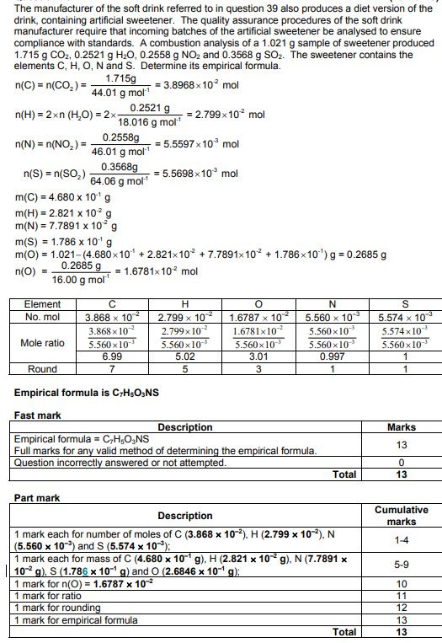

1. Sevoflurane is a gaseous compound (at room temperature) used for inducing and maintaining general anaesthesia. It contains carbon, hydrogen, oxygen and fluorine. Analysis of a 1.6328 g sample of sevoflurane yielded, on combustion, 866.0 mL of carbon dioxide at 50°C and 101.3 kPa and 0.220 g of water. The fluorine was released as hydrogen fluoride and absorbed by alkaline solution, revealing 5.71 × 10–2 mole of hydrogen fluoride. Determine the empirical formula of sevoflurane

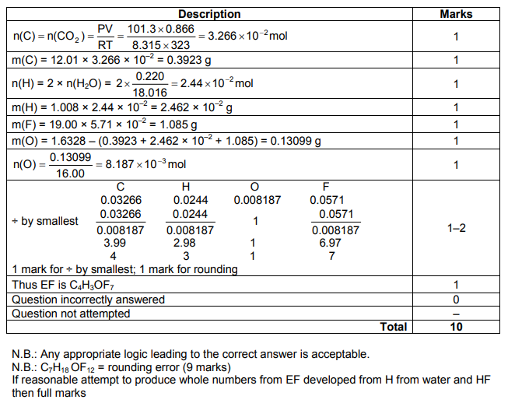

1. Qualitative analysis of an organic compound showed that it contained carbon, hydrogen and oxygen only. A quantitative study of the same compound was performed, in which a 0.5096 g sample was burnt in excess oxygen to produce 0.4160 g of water and 700.7 mL of carbon dioxide, collected at 100.0°C and 102.8 kPa.
2. Determine the empirical formula of the compound
3. A second 0.4832 g sample of the compound was heated to 261°C. The vaporised sample was found to exert a pressure of 241 kPa in a 100.0 mL container. Use this information to determine the molecular formula of the compound. (4 marks)
4. When the compound was reacted with acidified ethanol it produced a fruity smelling liquid. Infer the structure of the original compound, and draw its structure in the box below. Name the original compound
5. Describe briefly and give observations for an additional chemical test to confirm the identity of the functional group in the original compound. (2 marks)

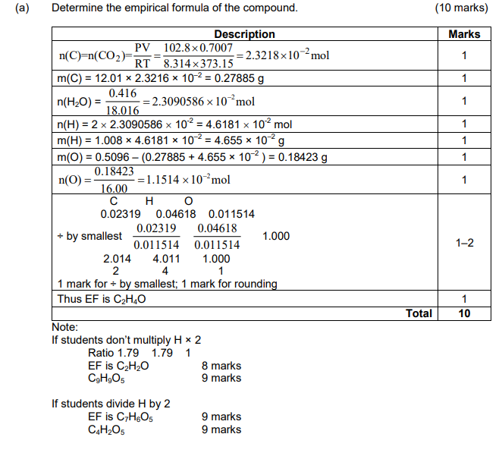

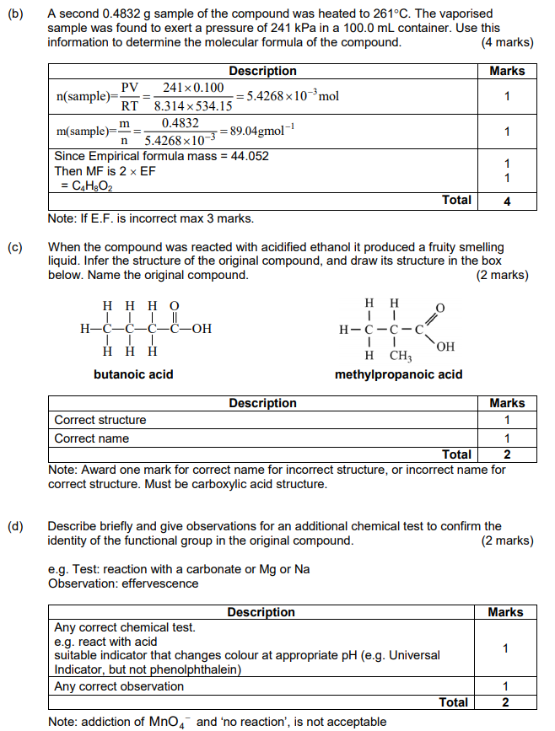

1. (a) A white solid is analysed and found to have the empirical formula CHO and a molar mass of 116 g mol–1

(b) Two tests were conducted on the solid, as shown in the table below. Complete the table by drawing a possible functional group that is consistent with the finding of each of the tests. (2 marks)

(c) A further 2.32 g sample of the white solid was analysed and shown to release 0.0400 mol of H+ ions. Use this information and your answers to (a) and (b) to determine the structural formula of the white solid, and draw it in the box below. Show all atoms in your structure.

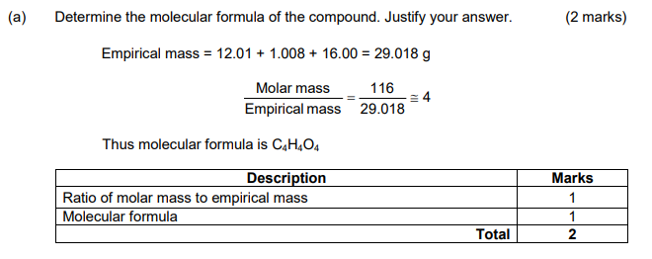

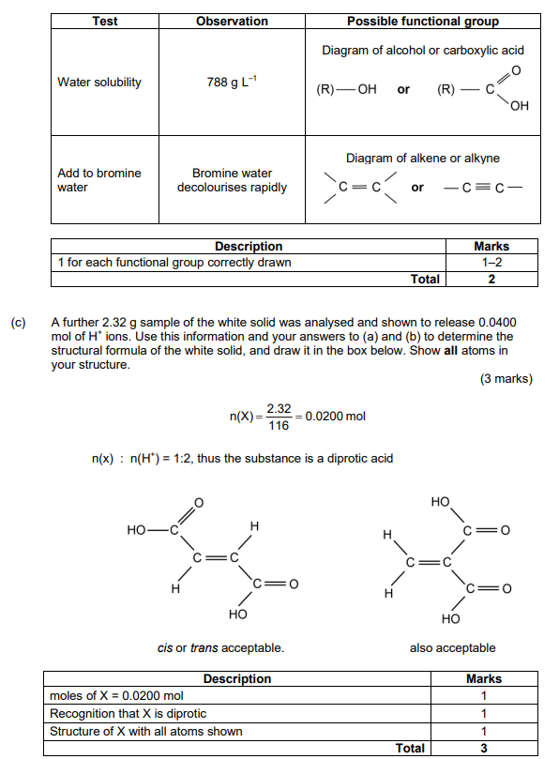**(b)**